PipeLine 5: An Addendum to the PipeLine 4 User’s Guide

PipeLine 5: An Addendum to the PipeLine 4 User's Guide

USAID | DELIVER PROJECT, Task Order 1
The USAID | DELIVER PROJECT, Task Order 1, is funded by the U.S. Agency for International Development under contract no. GPO-I-01-06-00007-00, beginning September 29, 2006. Task Order 1 is implemented by John Snow, Inc., in collaboration with PATH; Crown Agents Consultancy, Inc.; Abt Associates; Fuel Logistics Group (Pty) Ltd.; UPS Supply Chain Solutions; The Manoff Group; and 3i Infotech. The project improves essential health commodity supply chains by strengthening logistics management information systems, streamlining distribution systems, identifying financial resources for procurement and supply chain operations, and enhancing forecasting and procurement planning. The project also encourages policymakers and donors to support logistics as a critical factor in the overall success of their health care mandates.

Recommended Citation
USAID | DELIVER PROJECT, Task Order 1. 2010. PipeLine 5: An Addendum to the PipeLine 4 User's Guide. Arlington, Va.: USAID | DELIVER PROJECT, Task Order 1.

Abstract
The pipeline monitoring and procurement planning system (PipeLine) is a software tool that helps program managers—
• gather critical forecasting information
• ensure that products arrive on time
• maintain consistent stock levels at the program or national level
• prevent stockouts.
This guide (addendum) provides basic information on how to use PipeLine 5. It complements and should be read in conjunction with the PipeLine 4.0 User’s Guide.

Cover Photo: Woman using a computer in Rwanda.

USAID | DELIVER PROJECT
John Snow, Inc.
1616 Fort Myer Drive, 11th Floor
Arlington, VA 22209 USA
Phone: 703-528-7474
Fax: 703-528-7480
Email: askdeliver@jsi.com
Internet: deliver.jsi.com

Conventions

Introduction
This table lists the conventions used in this manual, which will make the manual easier to understand.

CONVENTION | MEANING
< > | Identifies keyboard keys (i.e., <Enter>, <Esc>, <F10>, <Alt>, <Ctrl>, <Back Space>, etc.).
 | Note  Identifies points of importance.
Helpful Hint
Identifies points that can speed up or ease an operation.
!! | Important  Indicates points you must consider before taking any action.
 | Warning  Indicates actions that will permanently change the data or adversely affect the system.
Italic Print | Words that need special attention.

Contents
GETTING STARTED 1
Introduction 1
System Requirements 1
How to Install PipeLine 2
Before You Begin 2
Installing PipeLine from a CD 3
Installing PipeLine from the Internet 3
How to Start PipeLine 3
Starting PipeLine from the Windows Desktop 4
Starting PipeLine from the Windows Taskbar 4
Reinstalling PipeLine 4
Converting Your Existing Data Files 4
On-Line Help 5
Multi-Language Features 6
CONSUMPTION-RELATED ENHANCEMENTS 7
Summary 7
Consumption 7
Adding Consumption Data 7
Editing Consumption Data 9
Cloning Consumption Data 10
Interpolating Consumption Data 12
Deleting Consumption Data 14
Recalculating Average Monthly Consumption (AMC) 15
SHIPMENT-RELATED ENHANCEMENTS 19
Summary 19
Shipments 19
Adding Shipment Data 19
Searching Shipment Data 22
Editing Shipment Data 24
Copying Shipment Data 24
Plan Shipments By Date 25
Deleting Shipment Data 25
Transfer Shipment Data 26
Funding Sources 31
Adding a Funding Source Option 32
Editing Funding Source Options 33
Deleting a Funding Source Option 33
NEW REPORTS AND RELATED ENHANCEMENTS 35
Summary 35
Stock Status Matrix Report 35
Creating the Stock Status Matrix Report 35
Supply Plan Report 38
Creating the Supply Plan Report 38
Stock Status Report—See Multiple Products Over One Month 40
Creating the Stock Status Report with Multiple Products Over One Month 40
Selecting Predefined and User-Defined Time Periods for Graphs and Reports 43
Select Predefined Time Period 43
Select User-Defined Time Period 43
Showing and Hiding Report Data 44
Showing Report Data 44
Hiding Report Data 45
Previewing and Printing PipeLine Reports 45
Previewing a Report 45
Office Links 45
Printing a Report 46
Creating a PDF of a Report 46
Appendix A 47
Frequently Asked Questions 47

Getting Started

Introduction
This release of PipeLine Monitoring and Procurement Planning System (PipeLine) addresses issues that existing users indicated were important to them. The revisions do not significantly change PipeLine’s purpose; the changes acknowledge that PipeLine is now used for many products other than family planning. The changes reflect the increasing complexity of forecasting for multiple products, new systems being used to schedule shipments within the USAID | DELIVER PROJECT and Supply Chain Management Systems (SCMS) project, and the vast number of products that data users must now regularly update.
This addendum to the PipeLine 4 User’s Guide describes the software enhancements in detail; it refers to the existing sections of the PipeLine 4 user’s guide for additional instruction, when necessary. This section explains how to install PipeLine. For questions about running PipeLine, contact the PipeLine product manager at the following address:
USAID | DELIVER PROJECT
John Snow, Inc.
1616 Fort Myer Drive, 11th Floor
Arlington, VA 22209 USA
Phone: 703-528-7474
Fax: 703-528-7480

System Requirements
The following resources are recommended for use with PipeLine.
CPU | Pentium III or higher
Operating System | Windows XP and above
Memory (RAM) | 1 GB
Hard Drive Space | 500 MB
Video Adapter | SVGA with 800 x 600 resolution
Miscellaneous | Microsoft Office 2003 Service Pack 2

How to Install PipeLine
 | Although PipeLine will run without Microsoft Office® 2003 installed on your computer, having Office 2003 installed will enhance PipeLine’s usefulness by allowing PipeLine to export data files to Word® or Excel®.
You can install PipeLine from a CD-ROM or from the Internet.

Before You Begin
You can run PipeLine 2 and PipeLine 5 on the same computer, but we recommend that you uninstall PipeLine 2 before installing PipeLine 5.
To uninstall PipeLine 2—
 | All other previous versions of PipeLine, except version 2, cannot be run on the same computer as PipeLine 5. When you install PipeLine 5, the installer will automatically remove the previous version of PipeLine prior to installing PipeLine 5.
- Click on Start.
- Click on the Settings option.
- Click on the Control Panel option.

After the Control Panel window opens—
- Click on the Add/Remove Programs option.
Locate and click on PipeLine in the Currently Installed Programs list.
- Click on the Change/Remove button.
The PipeLine 2 setup program will start; it will prepare your computer to uninstall PipeLine 2.
- Click on the Remove All button.

A message is displayed asking if you want to remove PipeLine.
- Click on the Yes button to begin the uninstall procedure.
When the uninstall procedure is completed, you will be prompted to restart windows.
 | Data files created with previous versions of PipeLine are not removed from your system. See Converting Your Existing Data Files on page 5 for information on converting your existing PipeLine data files.
- Click on the Restart Windows button.

Installing PipeLine from a CD
- Start Microsoft Windows.
- Insert the PipeLine CD.

The PipeLine installation should begin automatically.
- Follow the on-screen instructions.
- If the installation does not begin automatically—
- Click on Start on the Windows Taskbar.
- Click on Run from the pop-up menu.
- In the Command Line box, type x:setup (x is the letter of your CD-ROM drive).
- Click on the OK button, and follow the on-screen instructions.
After PipeLine is successfully installed, the PipeLine shortcut (shown at right) will be displayed on your desktop.
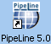

Installing PipeLine from the Internet
PipeLine is available on the USAID | DELIVER PROJECT website at the following web address:
http://deliver.jsi.com.
To download PipeLine—
 | If your Internet connection is slow and/or unreliable, order the PipeLine CD-ROM by emailing askdeliver@jsi.com or contacting the USAID | DELIVER PROJECT by phone or mail, using the contact information found in this manual.
- Access the Internet; enter the USAID | DELIVER PROJECT web address (http://deliver.jsi.com).
- Locate the PipeLine download page; follow the on-screen instructions to download PipeLine.
 | The Internet copy of PipeLine requires a password to begin the install process. The password will be sent by email. You must have a valid email address to receive the password.

How to Start PipeLine
You can start PipeLine from the Windows desktop or the Windows taskbar.

Starting PipeLine from the Windows desktop
From the Windows desktop—
- Locate and double-click on the PipeLine icon to start the application.

Starting PipeLine from the Windows taskbar
From the Windows taskbar—
- Click on Start.
- Click on Programs.
- Locate and click on the PipeLine 5.0 link.

Reinstalling PipeLine
To reinstall PipeLine—
- Place the PipeLine CD in your CD-ROM drive.
If you do not have the PipeLine CD, use the copy of PipeLine you downloaded from the USAID | DELIVER PROJECT website.
 | The Internet version of PipeLine requires a password to start the install process. You were sent that password by email when you downloaded PipeLine. If you no longer have the email with the PipeLine password, download PipeLine again from the USAID | DELIVER PROJECT website (http://deliver.jsi.com).
- Start the install process; follow the instructions on your screen.

During the process, a message box is displayed instructing you to remove PipeLine from your computer.
- Click on the Remove button to remove PipeLine from your computer.
- Click on the Finish button when prompted.

After PipeLine has been removed—
- Repeat the PipeLine installation procedure.
See page 2 for information on installing PipeLine.

Converting Your Existing Data Files
This version of PipeLine enables you to convert data created with previous versions of PipeLine.
From the Program Data screen—
- Click on the File Menu Bar option; select the Open option from the pull-down menu.
PipeLine opens a window to enable you to locate the data you need to convert.
 | PipeLine files have the data file extension .mdb
- Locate and select the data file you need; click on the Open button.
After you select the data file you need to convert, PipeLine displays a message similar to the one in the text box below.
The current program’s data file is not the current version. You can allow PipeLine to upgrade the file now. If you do not, some of PipeLine’s features may not work correctly.

- Click on the Yes button to convert the selected data.
PipeLine opens a window, enabling you to rename the file you selected to upgrade. The upgraded data are saved as a new file, and the original data remain in the previous version’s format. This safeguards the original data by saving the upgraded data under a different name.
- Type the new name in the File Name field; click on the Open button.
PipeLine converts the selected data, renames the file, and displays its associated program data on the Program Data screen. You can now work with the converted data file.
 | Remember, your original data remains in its original directory with its original name. The converted data is a copy of the original.

On-Line Help
PipeLine’s On-Line Help is a supplement to the PipeLine 4 User's Guide. On-Line Help provides information about basic PipeLine functions.
- Press the <F1> key to access On-Line Help.
 | Information in this addendum is not included in the On-Line Help.

Multi-Language Features
At this time, PipeLine 5 is only available in English. Multiple language translations of PipeLine 5 are currently unavailable. If you want to use PipeLine in Arabic, French, Portuguese, or Spanish, you should continue to use PipeLine 4. PipeLine 5 may be made available in other languages in the future, if resources permit translation of the software and user documentation.

Consumption-Related Enhancements

Summary
PipeLine has three new consumption-related enhancements:
- cloning forecast consumption
- interpolating future consumption
- recalculating average monthly consumption (AMC).

Consumption
Use the Consumption Tree View option to track actual or forecast quantities of products dispensed to users.
- Actual Consumption—reported or estimated quantities of product that left the program’s logistics system through normal dispense-to-clients activities.
- Forecast Consumption—quantities expected to be dispensed in the future.
- Click on the Consumption Tree View option.
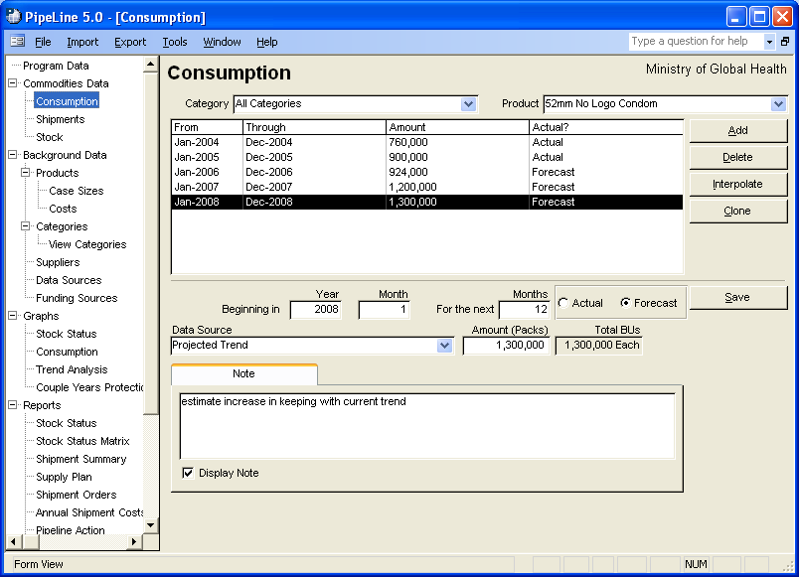Figure 1—Consumption screen
PipeLine displays the Consumption screen (see Figure 1).

Adding Consumption Data
To add consumption data from a file generated by an external forecasting system, see PipeLine Utilities – Import Consumption Data section of the PipeLine 4 User’s Guide (page A-6). Use the Add button to add consumption data for a particular product.
 | At this time, forecast consumption data can be imported from the Quantimed software package (available from Management Sciences for Health [MSH]). PipeLine may be able to receive consumption data from additional sources in the future: check with the PipeLine product manager at the USAID | DELIVER PROJECT for details.
With the Consumption screen displayed—
- Click on the arrow next to the Category field; select a category from the pull-down menu.
- Click on the arrow next to the Product field; select the product where you want to add consumption data.
- Click on the Add button.
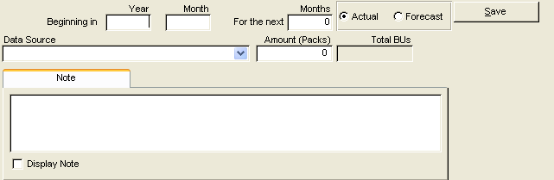
Figure 2—Consumption screen data entry area
The lower half of the Consumption screen becomes blank to allow you to enter data (see Figure 2).

Beginning In
This area enables you to set the consumption period, which can be any number of months.
The Year field shows the calendar year when the consumption period begins.
- Type the four-digit year.
The Month field shows the month that marks the start of the consumption period. For example, 1 shows that the first month of the year is the start of the consumption period.
- Click in the Month field; type the month when the consumption period begins.

For the Next
The For the Next Months field shows the number of consecutive months in the consumption period. For example, 3 indicates a period of three months (one quarter).
- Click in the For the Next Months field; type the length of the consumption period (in months).
The Actual field shows that the consumption data comes from an actual source (for example, physical inventory records, dispense logs, etc.).
- Click on the Actual field if the consumption data comes from an actual source.
The Forecast field shows that the consumption data is an estimated projection.
- Click on the Forecast field if the consumption data comes from a forecast estimate.
The Data Source field shows the type of data used to compute consumption.
- Click on the arrow next to the Data Source field; select a data source from the pull-down menu.
The Amount field shows the amount of consumption for this period. To calculate consumption for reports and graphs, this amount is divided by the number in the For the Next Months field.
- Click in the Amount field; type the consumption amount.
The Note field is a memo area used to include additional information about the data.
 | Total consumption in Basic Units (BUs) is automatically displayed. This is your consumption amount in packs converted to basic units (pack times pack size). The default basic unit is one per pack. You can update basic units in the Products screen, under the Availability/UOM (unit of measure) tab, if the product you are working on has a different basic unit-to-pack ratio.
- Click on the Note field; type any relevant notes about the consumption data.
The Display Note field tells PipeLine to include the note in the PipeLine reports.
- Click on the Display Note field to include the note in reports.
- Click on the Save button to save the data.

Editing Consumption Data
You can edit the Consumption data for a particular product.
With the Consumption screen displayed—
- Select the Category for the product you want to edit.
 | If you do not remember the name of the category for the product you need to edit, select All Categories from the Category pull-down menu to access all the products in your program.
- Click on the arrow next to the Product field; select the product you need to edit from the pull-down menu.
- Click on the consumption data you need to edit.
- Click in the field you need to edit; type the new data.
- Click on the Save button to save the data.

Cloning Consumption Data
This enhancement enables you to clone forecast consumption data from one product to multiple other products, according to a user-defined factor of basic units. It helps you enter forecast consumption data faster into the Consumption screen in PipeLine, especially for products that are used together in a fixed ratio. It could be useful for products, such as lab supplies, drugs used in fixed combinations, and consumable health supplies (such as syringes).
To successfully clone consumption data, the following conditions must be met:
- The product being cloned and its forecast consumption data are entered into PipeLine.
- The product(s) receiving the cloned data must also be entered into PipeLine.
  - You do not need to enter any forecast consumption data for the product receiving cloned data.
  - Any existing consumption data marked as actual will not be overwritten.
- The ratio in which the products are used is known.
  - All ratios are entered in basic units, not packs.
!! | How is this feature different from PipeLine 4.0?  This feature was not available in PipeLine 4.0. Each product and its consumption data had to be manually entered, unless it was imported from a forecast produced in Quantimed.
With the Consumption screen displayed—
- Select the Category for the product you want to clone.
- Click on the arrow next to the Product field; select the product you want to clone from the pull-down menu.
- Click on the Clone button.
!! | If consumption data does not exist for the product selected, the Clone button will be disabled.
The Clone Consumption window is displayed (see Figure 3). This window indicates the selected product and enables you to select the time period to begin cloning data. After selecting OK, the product(s) to clone and the factor(s) by which they are cloned will be entered.
!! | You cannot clone historical data. You can only clone data from the current or future months. Therefore, the starting month for the clone procedure must be either the current month or a future month.
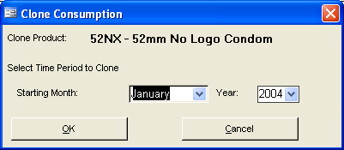
Figure 3—Clone Consumption window
- Click on the Select field for each product you want to clone.
- Click on the Ratio field; enter the factor by which the cloned consumption data should be modified for each selected product. Factors must be ratios of basic units!
To preview a table with the results of the cloning operation—
- Click on the Preview button.
The report is displayed onscreen. If you are satisfied with the data as presented, you can print the report from the preview screen. Using the toolbar, you can export the report to Word, Excel, or a PDF. After the report is closed, you will return to the Clone Consumption screen.
To populate the target product(s) to be cloned and generate a Cloning Report—
- Click on the Apply button.
A confirmation report is displayed on the screen. You can print the report from the preview screen. Using the toolbar, you can export the report to Word, Excel, or a PDF. After the report is closed, you will return to the Consumption screen.
!! | Cloned consumption is always marked as forecast. Cloned data are entered monthly; the data source of cloned consumption is automatically entered as clone.

Interpolating Consumption Data
This enhancement enables you to interpolate future consumption data between a defined start point and a defined end point. Interpolation calculates values along a straight line between the two points. The start point is the last point of the existing consumption data for the selected product; the starting average monthly consumption is the actual average monthly consumption reported for that point in time. The end point is a user-input value. You also input the forecast (or targeted) ending average monthly consumption. PipeLine will enter a monthly consumption value for each month in the desired date range based on the interpolation between the starting point and the ending point. Interpolation can also be used for a completely new product that has no prior consumption history. However, the function will not populate consumption data for a previous time period. Only future consumption records (forecast) can be created with interpolation.
The interpolate function is useful if you are forecasting based on a future target, especially for products with no or little prior consumption history. Any consumption record marked as actual will not be overwritten by the interpolate function; only forecast consumption can be entered this way.
 | How is this feature different from PipeLine 4.0?  This feature was not available in PipeLine 4.0. Each product and its consumption data was manually entered, unless it was imported from a forecast produced in Quantimed.
With the Consumption screen displayed—
- Select the Category for the product you want to interpolate.
- Click on the arrow next to the Product field; select the product you want to interpolate from the pull-down menu.
- Click on the Interpolate button.
If there is no actual consumption for the product selected, a message is displayed (Figure 4).
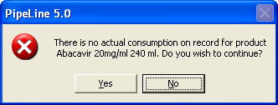
Figure 4—Actual consumption warning message
- Click Yes to continue.
The Interpolation window is displayed (see Figure 5). This window enables you to enter the starting and ending month, year, and average monthly consumption (AMC).
 | Click No and you will return you to the Consumption screen with no changes to the system.
- Click on the arrow next to the Starting Month field; select the month for starting your interpolation.
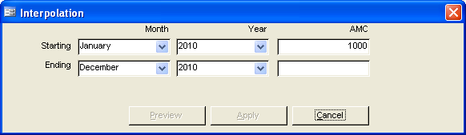
Figure 5—Interpolation window
- Click on the arrow next to the Starting Year field; select the year for starting your interpolation.
- Enter the starting AMC for your interpolation in the Starting AMC field.
- Press Enter.
 | If actual consumption is on record for the previous two years, the starting month is set to the last month and year for which there is actual consumption. The starting AMC is the AMC value for that month and year as calculated in the Stock Status Report. All these starting values will be disabled; you cannot change them through the Interpolate function.
- Click on the arrow next to the Ending Month field; select the month to end your interpolation.
- Click on the arrow next to the Ending Year field; select the year to end your interpolation.
- Enter the ending AMC for your interpolation in the Ending AMC field.
- Press Enter.
To preview a table of the results of the interpolation operation—
- Click on the Preview button.
The report is displayed onscreen. If you are satisfied with the data as presented, you can print the report from the preview screen. Using the toolbar, you can export the report to Word, Excel, or a PDF. After the report is closed, you will return to the Interpolation window.
To interpolate the target product based on these values—
- Click on the Apply buttton.
If forecast data already exists for the select product and time period, a warning message will be displayed (see Figure 6).

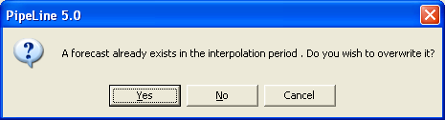
Figure 6—Overwrite warning message
- Click Yes to continue with the interpolation and overwrite the existing forecast.
Or, click No to continue with the interpolation and only add new forecast records.
Or, click Cancel to cancel the interpolation and return to the Interpolation window.
A confirmation message will be displayed indicating changes that were made to the selected product (see Figure 7).
- Click on the OK button.
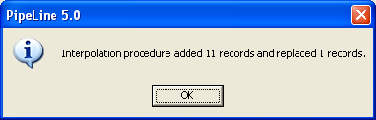
Figure 7—Interpolation confirmation message

Deleting Consumption Data
Use the Delete button to delete the consumption data for a particular product.
With the Consumption screen displayed—
- Click on the Category field; select the category from the pull-down menu.
- Click on the arrow next to the Product field; select the product that you need to delete consumption data from.
- Click on the consumption data you need to delete.
- Click on the Delete button; a confirmation message is displayed.
- Click on Yes to delete the selected consumption data.

Recalculating Average Monthly Consumption (AMC)
One of the most important statistics used in PipeLine is average monthly consumption (AMC), which is used to calculate stock status and replenishment quantities. The default AMC calculation is the average of the consumption over three months—the current month plus the next two forecast months, divided by three. This default works very well when the variance in demand is random. However, for products with a strong seasonal component to the demand, particularly products that must be pushed and pre-positioned before an event, demand will be over- or under-estimated in PipeLine when the default setting is used. To compensate for long in-country pipelines and seasonal demand, PipeLine 5 has a new feature that enables you to reset the AMC calculation using a different number of months. Recalculating AMC enables you to take advantage of PipeLine’s shipment planning features to avoid stock shortages during the high consumption period and to avoid overstocking during the low consumption period.

Seasonal goods might include antimalarials and other materials for seasonal epidemics, or products for campaigns and promotions. It is important to remember that the seasonal component of demand is a predictable spike in demand that is independent of any other consumption trends over time.

Recalculating AMC has two parts. First, you can select a starting month and year in the future to begin planning (to pre-position the products ahead of the increase in demand); second, you can select the number of months to use to calculate AMC. Calculating over a longer period, where appropriate, enables you to either capture the seasonal demand in a single shipment or to even out the requirement into approximately equal shipments.

Although Recalculate AMC affects consumption data, it is manipulated from the Stock Status Report screen; this enables you to see the average monthly consumption figures.

With the Stock Status Report Screen displayed—
- Select the product whose average monthly consumption you want to recalculate.
It is not necessary to display data before recalculating AMC; however, before recalculating, it is recommended that you view your data using the Show Data button (see Figure 8).
- Click on the Recalculate AMC button.
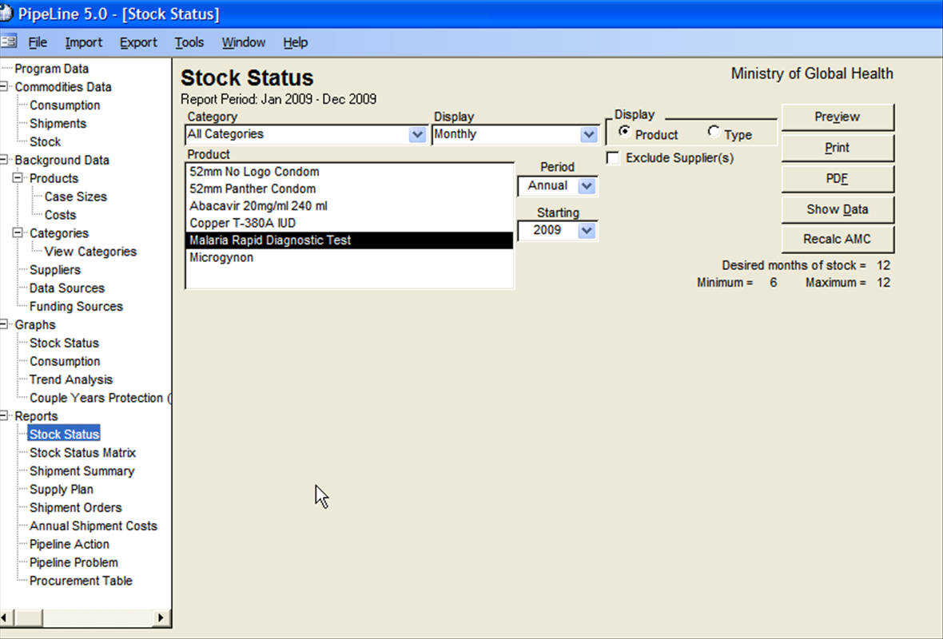
Figure 8—Stock Status report screen
The Recalculate AMC window is displayed (see Figure 9). PipeLine’s default parameters for the AMC calculation are shown.
 | PipeLine’s defaults are a three-month average for AMC calculation; it begins in the current month—that is, the first month shown in the stock status report.

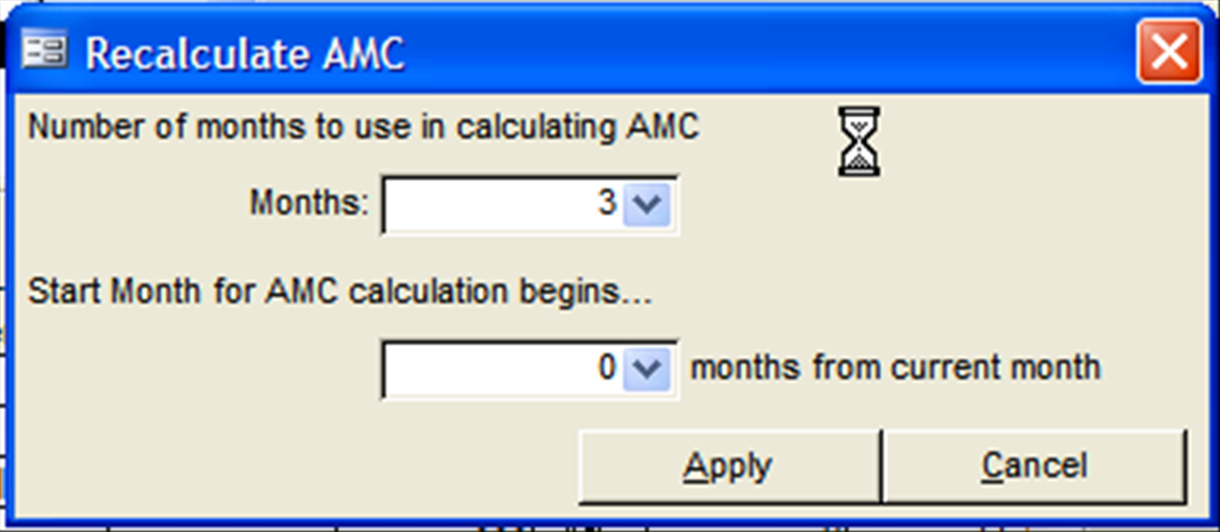
Figure 9—Recalculate AMC window

- Adjust the AMC calculation parameters to meet your shipment requirements.
You should experiment with your data to determine the best combination of parameters to use. The following are suggested guidelines for setting the recalculate AMC parameters for products with strong seasonal consumption fluctuations:
To set the parameter for the number of months to use in calculating AMC, select a number from 1–12 that includes the seasonal increase in consumption expected for the product you selected. For example, if the seasonal increase in consumption occurs over three months, select an average of five months, which will capture one month before and one month after the consumption increases in the rolling average.
To set the parameter for the start month of the AMC calculation, use the number of months that correspond to your desired end of year stock (DEOYS). DEOYS usually equals—
(Minimum + Maximum + Order Interval) / 2
This ensures that planned shipments will arrive ahead of the anticipated spike in consumption.
- Select Apply to recalculate the average monthly consumption.
Data in the Stock Status Report are changed according to the selected parameters. Shipment planning can now proceed, as described in the PipeLine 4 User’s Guide (see section 5).
 | To reset the AMC to PipeLine’s default calculation, select Recalculate AMC again; change the parameters to three months for number of months used in calculating AMC. Set the start month for the calculation to zero months from the current month.

Shipment-Related Enhancements

Summary
Four shipment-related enhancements have been added to the software.
- Search Shipments on ID#
- Funding Source
- New Shipment Status: Arrived
- Transfer Shipments Between PipeLine Databases.

Shipments
Use the Shipment Tree View option to add, modify, and delete shipping data.
- Click on the Shipments Tree View option to display the Shipments screen (see Figure 10).
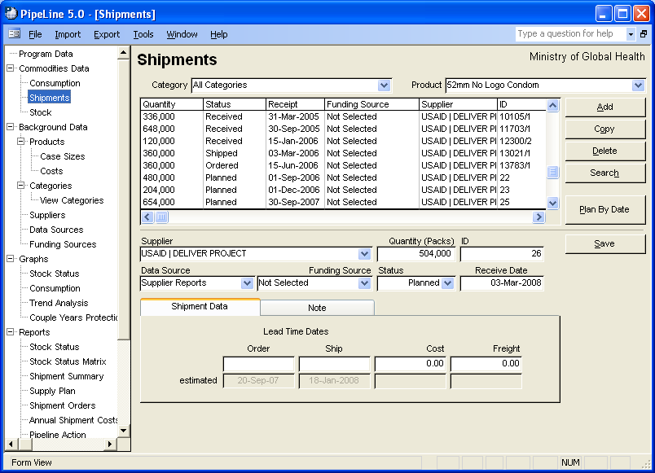

Figure 10-—Shipments screen Adding Shipment Data
Use the Add button to add shipment data to a particular product.
With the Shipments screen displayed—
- Click on the arrow next to the Category field; select the category from the pull-down menu.
- Click on the arrow next to the Product field; from the pull-down menu, select the product receiving the shipment data.
- Click on the Add button.
The lower-half of the Shipment screen becomes blank (see Figure 11), enabling you to enter new data. The Supplier values will drop down (not shown), and the Status field will display a default value of Planned.
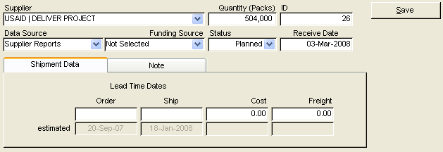
Figure 11—Shipments screen data entry area
- Select the shipment’s supplier from the pull-down menu.
- Click in the Quantity field; type the shipment quantity (in units).
The ID field uniquely identifies the shipment. You can use the Requisition Order number, a purchase order number, an invoice number, or any other unique identifier. You can also accept the PipeLine-generated code.
To enter a code of your choice—
- Click in the ID field; type the shipment ID.
 | The shipment ID can be any combination of numbers, letters, and spaces, up to ten characters.
The Data Source field shows the data source associated with the shipment record.
- Click on the arrow next to the Data Source field; select the data source from the pull-down menu.
The Funding Source field shows the funding source associated with the shipment record.
- Click on the arrow next to the Funding Source field; select the funding source from the pull-down menu.

Shipment Status
PipeLine 5.0 includes a new shipment status—arrived—to provide detailed options for tracking and sorting shipments. A shipment is considered arrived after it has arrived in-country but has not been received at the warehouse from which it will be distributed to clients.
In many countries, lengthy customs procedures often mean that a shipped product is at port but not yet cleared from customs and available for use by clients. This shipment status helps PipeLine users account for and track such shipments. The status will show in reports, such as the Shipment Orders report; it may be included or excluded from the report at your discretion (as with status of all other shipments).
 | How is this feature different from PipeLine 4.0?  This feature was not available in PipeLine 4.0. In 4.0, only four shipment statuses were available: planned, ordered, shipped and received. A received shipment is one that has been received at a warehouse and is ready for distribution to or for use by clients. There was no status other than shipped for a shipment that had been sent by its supplier but not yet received at the warehouse.
The Status field shows the shipment’s status. The default value for this field is Planned. To change the default value—
- Click on the arrow next to the Status field; select the shipment status from the pull-down menu.
The Receive Date field shows the date the shipment was or is expected to be received.
Every shipment record must have a receipt date.
- Click in the Receive Date field; type the shipment’s receipt date.
After a value is entered in the Receive Date field, depending on the quantity entered and the background product information, a message window will be displayed, which notes that the quantity entered does not reflect the Product/Supplier case size. PipeLine will prompt you to round the value to the nearest Product/Supplier case size (see Figure 12). Select Yes or No.

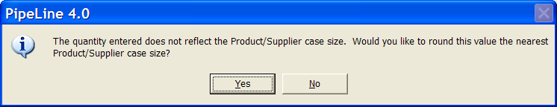
Figure 12—Case size adjustment message

Shipment Data Tab
The Shipment Data tab displays the shipment’s actual or estimated lead times and the shipment and freight cost.

Order (actual/estimated)
The top field shows the actual date the shipment was or is to be ordered. The Estimated field is calculated based on the lead times for the supplier. To override the estimate—
- Click on the top field; type the shipment’s order date.

Ship (actual/estimated)
The top field shows the date the shipment was or is to be shipped. The Estimated field is calculated based on lead times for the supplier. To override the estimate—
- Click on the top field; type the ship date.

Cost (actual/estimated)
The top field shows the shipment’s actual cost. The Estimated field is calculated based on the product’s current effective product cost on the ship date. To override the estimate—
- Click on the top field; type the shipment’s exact cost.

Freight (actual/estimated)
The top field shows the actual freight cost. This amount includes any additional charges (i.e., clearance fees) incurred while the product is being delivered. The estimated field shows a calculation based on a percentage of the product cost. To change the estimate—
- Click on the top field; type the shipment’s actual freight cost.
The Note Tab has a memo field for additional information about the shipment.
 | If you enter actual shipment information—such as receipt date or freight cost (overriding PipeLine’s estimates)—the actual information you entered will be displayed in all the PipeLine reports.
- Click on the Note Tab; type any relevant notes about the shipment.
The Display Note field tells PipeLine to include the note in the PipeLine reports.
- Click on the Display Note field to include the note in the PipeLine reports.
- Click on the Save button to save the data.

Searching Shipment Data
You may now search for a shipment ID# or fragment of an ID# from the Shipments screen. The search function enables you to input up to 10 alpha-numeric characters. All shipment records for all products are searched for the user-input ID; results are displayed in numeric order and are highlighted on the screen. If only one record is returned, PipeLine will change the screen to show that product’s shipments and will highlight the matching record. If multiple records match the search, PipeLine will display the number of matching records and focus on the first match. You can scroll through each record until the desired match is found.
With the Shipments screen displayed—
 | How is this feature different from PipeLine 4.0?  This feature was not available in PipeLine 4.0.
- Click on the Search button.
The Search Shipment ID# window is displayed (see Figure 13).
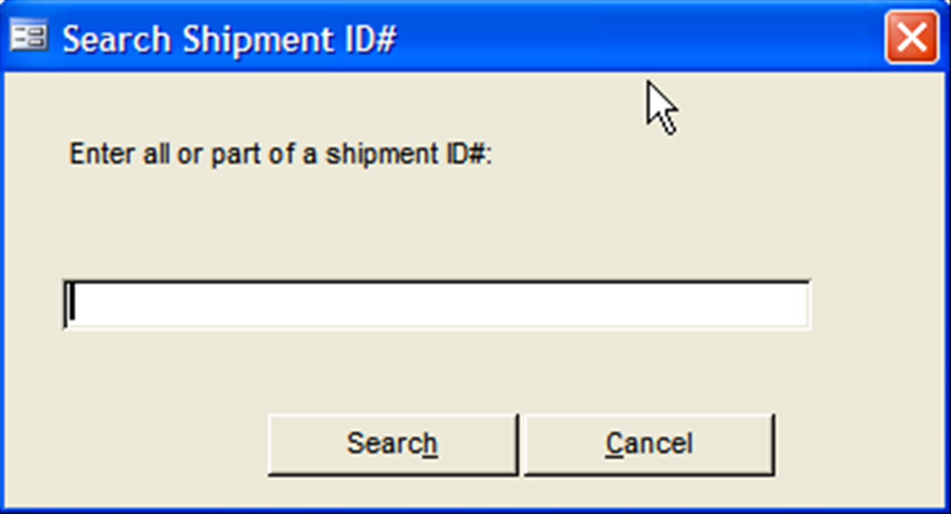
Figure 13—Search shipment ID# window

- Type all or part of a shipment ID# in the text box.
- Click Search button.
If the search is unsuccessful, a message box is displayed.
- Click OK to return to the Search Shipment ID# window.
If the search successfully returns ONE record, the Search Shipment ID# window closes, the appropriate Product is selected in the Product field, and the shipment record matching the search is highlighted on the Shipment Screen.
If the search successfully returns MULTIPLE records, a message box is displayed; the first shipment record matching the search is highlighted on the Shipment Screen, and the appropriate Product is selected.
- Click Next Record to focus on the next matching record from the search.
Continue to click Next Record until the record you are looking for is selected.
- Click Cancel to close the window and return to the Shipment screen.

Editing Shipment Data
You can edit Shipment data for a particular product.
With the Shipments screen displayed—
- Select the Category for the product you want to edit.
If you do not remember the category for the product you need to edit, select All Categories from the Category pull-down menu to access all the products in your program.

- Click on the arrow next to the Product field; from the pull-down menu, select the product you need to edit.
- Click on the shipment record you need to edit.
- Click in the field you need to edit; type the new data.
- Click on the Save button to save the data.

Copying Shipment Data
The Copy button enables you to copy shipment data. Copied data can be edited to reflect details of a new shipment, which reduces the amount of data entry required.
With the Shipments screen displayed—
- Click on the arrow next to the Category field; select the category for the product you need to copy shipment data from.
- Click on the arrow next to the Product field; select the product from which you need to copy shipment data.
- Select the shipment data you need to copy.
!! | You must enter a new receipt date in the Receive Date field.  PipeLine assigns a shipment ID number to the copied data. You can override PipeLine’s shipment ID number and use your own unique identifier.
- Click on the Copy button.
- Edit the shipment record, as needed.
- Click on the Save button to save the changes.

Plan Shipments By Date
Using PipeLine you can add shipments based on the amount of stock needed to reach a desired stock level, on a date you specify for selected products. Use the Plan By Date button to plan shipments.
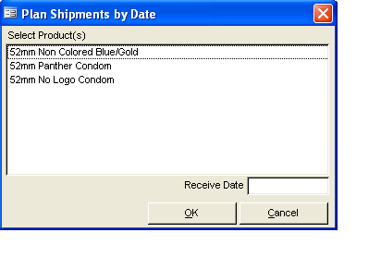
Figure 14-—Plan By Date window With the Shipments screen displayed—
- Click on the Plan By Date button.
The Plan By Date window is displayed (see Figure 14). This window includes every product in the currently selected category for the current program.
- Click on the product(s) you want to plan based on the product’s receipt date.
- Click in the Receive Date field; type the date you want the shipment(s) delivered.
- Click on the OK button.
If the receipt date you enter is not the last day of the current month, a message is displayed (see Figure 15)
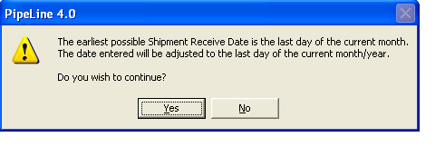
Figure 15—Plan by date shipment message
- Click on the Yes button to accept the date change.

Deleting Shipment Data
Use the Delete button to delete the shipment data of a particular product.
With the Shipments screen displayed—
- Click on the arrow next to the Category field; select the category from the pull-down menu.
- Click on the arrow next to the Product field; select the product from the pull-down menu.
- Select the shipment record you need to delete.
- Click on the Delete button; a confirmation message is displayed.
- Click on Yes to delete the selected shipment data.

Transfer Shipment Data
This enhancement enables you to export shipment data from one PipeLine database and import it into another PipeLine database. This feature may be useful if you have multiple databases for a single program (for example, if you have a national program supplied by two distinct supply chains: one database can be kept for the national program, while separate databases are used to track products in each supply chain). This enhancement frees you from having to manually enter updated shipment data into each database. Instead you can enter data in only one database and easily import it into any other database.
Shipment data are exported as extensible markup language (XML) files. The import feature matches existing shipments in the importing database to shipment data contained in the XML file based on the product ID and shipment ID.You can manually match shipments in an import screen, if they are not automatically matched; you can also preview the results of the import before committing to it. New shipments are also imported. Ultimately, it is your choice to import or not to import any shipment contained in the XML file.
To successfully import a shipment from another PipeLine database, the following conditions must be met:
- The Product, Supplier, Funding Source (if applicable), and Data Source must all exist in the importing database, as they do in the exporting database.
  - These fields must have the same names and codes in both databases. PipeLine will not import any shipments without these data.
  - You will be notified which shipments did not import at the top of the Preview report and at the top of the Confirmation report. On the report, an asterisk marks the Product, Supplier, Funding Source, or Data Source that do not exist in the importing database.

Exporting Shipment Data
 | How is this feature different from PipeLine 4.0?  This feature was not available in PipeLine 4.0. In 4.0, you could only enter shipments via import from an Excel spreadsheet and only for the initial setup of a database. Users that kept multiple existing databases for the same program had to manually enter all shipment updates into each database.
The Export option of the menu bar lets you export shipment data (see Figure 16).
To export shipment data—
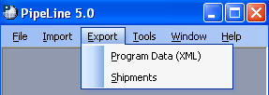
Figure 16—Export options
- Click on the Export Menu Bar option.
- Click on the Shipments option.

PipeLine displays the Save Output Data To window so you can save the current program data as an XML file (see Figure 17). PipeLine created the default file name based on the Program Code and the date.
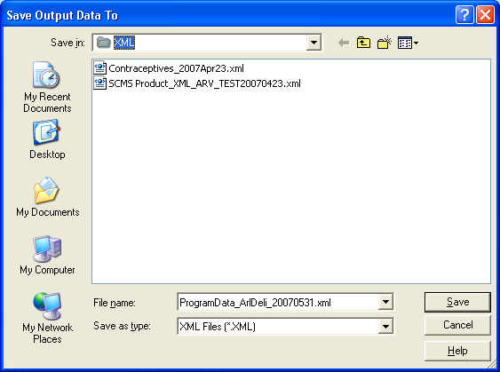
Figure 17—Save Output Data To window
- Click on the Save button to accept the default file name.
Or, type a new file name and click on the Save button.
PipeLine displays the Program Data Export (XML) window to notify you that the export of program data was successfully completed. This window shows the location of the newly created file.
Never save the data to your A:\ drive.
- Click OK.
Your previous location in PipeLine is redisplayed after the data is saved.
If you accidently select Export ->Program Data, you can go back to the previous screen; click the Cancel button on the Save Output Data To screen.

Importing PipeLine Shipment Data
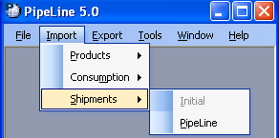
Figure 18—Import Shipment options
The Shipment Import option of the Import Menu Bar option will be available after you create and save a new program (see Figure 18). This option enables you to import data from other PipeLine databases.

To import shipment data—
 | This option is only available if you have access to an exported data file.
- Click on the Import Menu Bar option.
- Click on the Shipment option.
- Click on the PipeLine option.
PipeLine displays the Import Shipments window so you can select the data file to import (see Figure 19).
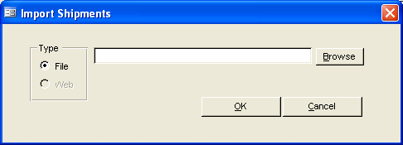
Figure 19—Import Shipments Data window

!! | Inside the Type box, be sure that the File radio button is selected. The functionality for the Web option is currently not available.
- Type the location of the data file you need to import.
If you are not sure where the forecast data file is located, use the Browse button. Click on the Browse button; use Windows Explorer to locate the file you need. Click on the file and click Open.
- Click OK.
Never import a file from the A:\ drive. Move the data from the A:\ drive to your hard disk, then use the Import Option to select the data.
After validating the file, PipeLine displays the Shipment Import Reconciliation window (see Figure 20).
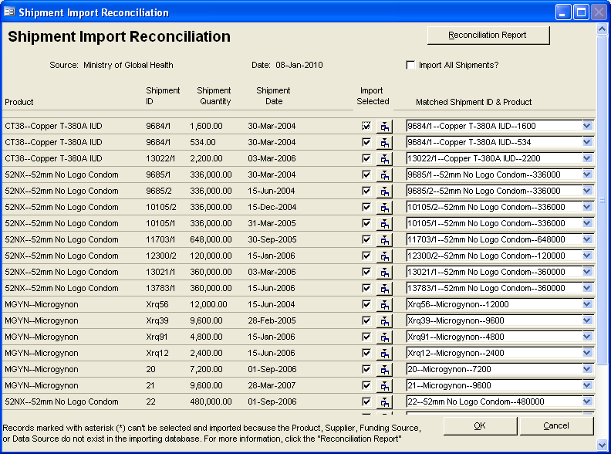
Figure 20—Shipment Data Import Reconciliation window

Reconciling Imported Shipment Data
The Shipment Import Reconciliation screen displays a list of all potential shipment data to be imported. The Source field displays the name of the source file for the import data.
The Date field displays the date the import file was created. The Import All Shipments? field identifies if all import values will be imported in the database.
- Check Import All Shipments? to import all shipments in the import file.
The Product column displays the Product Code and Product Name for the products in the imported shipment data file. The Shipment ID, Shipment Quantity, and Shipment Date fields display the values for the fields in the imported shipment data file. The Select field is used to select the product shipment data to be imported. The final column is used to map shipment data file records to the shipments displayed in the list.
To select shipment data for import—
 | All shipments that match a shipment in the shipment list based on Product ID# and Shipment ID will automatically be mapped.
- Click on the Select column for each shipment with data that you would like to import into PipeLine.
 | If you check the Select column for a product and then leave the Matched Shipment column blank, PipeLine will create a new shipment with this shipment data.  Records marked with an asterisk (*) cannot be selected and imported because the Product, Supplier, Funding Source, or Data Source do not exist in the importing database.
To associate a shipment record to be imported with shipments in the Matched Shipment List—
- Click on the arrow next to a data field in the Matched Shipment ID & Product column; select the shipment that corresponds to the imported shipment data.
- Repeat the process for each shipment that needs to be associated with a Shipment in the List.
To view the details of the Matched Shipment selected—
Just mapping shipment data to a shipment in the Matched Shipment ID & Product List will not import it. You must also check the Select column in the corresponding row.
- Click on the button.
- The Shipment Detail window will open (see Figure 21) and will display details of the existing shipment that have been matched to a shipment being imported. Click on the in the right-hand corner to close the window and return to the Reconciliation window.
The Reconciliation Report highlights any shipments that cannot be imported; it can be viewed prior to completing the import. To view the Reconciliation Report prior to importing the shipment data—
- Click on the Reconciliation Report button.
After you select the shipments to be imported and associate them to existing shipments, where applicable—
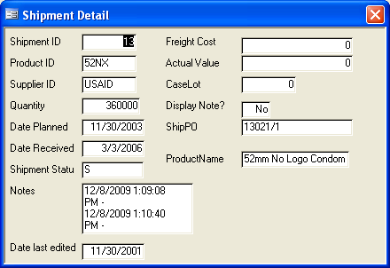
Figure 21-—Shipment Detail window
- Click on the OK button to complete the import.
After the selected shipment data is imported into PipeLine, the Import Report will be displayed. This report shows which shipments were imported with associated shipment data; it also lists any shipments that were not imported. Using the toolbar, you can export the report to Word, Excel, or a PDF.
After the report is closed, you will return to the main screen; you will be able to view the newly imported shipment data.
!! | The system does not save these reports; therefore, it is strongly recommended that you either export or print the report (before closing it).

Funding Sources
Funding source, a new field in PipeLine 5.0, gives you an additional way to describe a shipment. Funding source is an optional field that can be used or left blank. Funding sources are associated with shipments of products in the Shipments screen.
In many countries, shipments of various products are shipped by one entity but funded by another (for example, UNFPA can ship oral contraceptives but the shipment can be funded by a basket fund or the country’s funds). This enhancement makes it possible to differentiate between the organization physically shipping the product (the supplier) and the organization paying for the product (the funding source).
You define a funding source in the same way you define a supplier or data source—in a separate data entry screen where any funding source can be entered. Only two data points are required: the name of the funding source and a code (either the default code generated by PipeLine or a user-defined code that can be substituted for PipeLine’s default). Shipment-related reports, such as the Shipment Summary Report, Shipment Orders, and Annual Shipment Costs, can be sorted by funding source (as well as supplier), giving you additional options for viewing data.
- Click on the Funding Sources Tree View option to access the Funding Sources screen.
 | How is this feature different from PipeLine 4.0?  This field was not available in PipeLine 4.0. You were able to describe a shipment by product and supplier, but you could not easily distinguish an organization providing transport that was not also providing funding from an organization that was providing both.
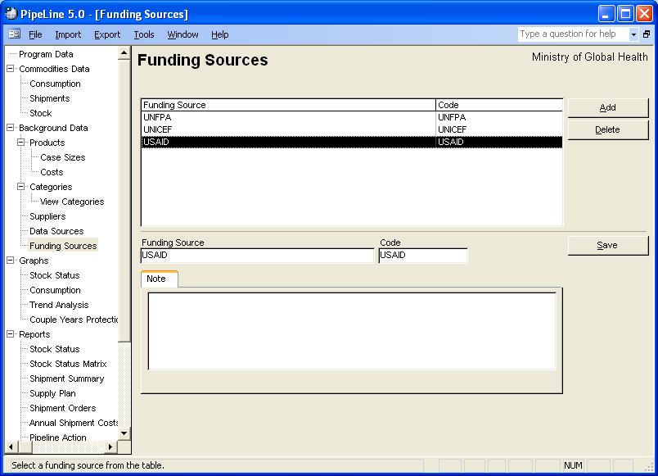
Figure 22—Funding Sources screen PipeLine displays the Funding Sources screen (see Figure 22).

Adding a Funding Source Option
Use the Add button to add a new Funding Source option.
- Click on the Add button.
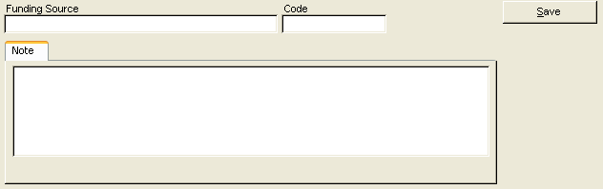
Figure 23—Funding Sources screen data entry area
The lower-half of the Funding Sources screen becomes blank to allow you to enter data (see Figure 23).
- Type the source name.
The Code field holds the code for the Funding Source's code, which identifies the Funding Source option. Data in the Code field is created based on the name you give the Funding Source option.
You may keep the PipeLine-generated code or use your own coding system.
To change the PipeLine-generated code—
- Highlight the PipeLine-generated code; type the new code.
- Click on the Save button to save the data.
 | You are limited to 10 characters for the code, which can be numbers, letters, spaces, or a combination of these.

Editing Funding Source Options
You can edit Funding Sources information:
With the Funding Sources screen displayed—
- Click on the Funding Source option you need to edit.
- Click in the field you need to edit; type the new data.
- Click on the Save button to save the changes.

Deleting a Funding Source Option
Use the Delete button to delete a Funding Source option.
With the Funding Sources screen displayed—
- Click on the Funding Source option you need to delete.
- Click on the Delete button.
If the Funding Source option can be deleted, PipeLine will display a confirmation.
- Click on Yes to confirm the delete.
If you cannot delete the Funding Source option (because it is associated with other database records), PipeLine will display a message window.
- Click on OK to close the message window.

New Reports and Related Enhancements

Summary
PipeLine has two new reports and three related enhancements:
- Stock Status Matrix report
- Supply Plan report
- View Stock Status of All Products for One Month
- User Defined Time Periods
- Formatting of numbers in Excel reports.

Stock Status Matrix Report
This new version of the Stock Status report provides you with another option for presenting data by showing the stock in months figure over a user-selected time period. The stock status matrix shows the stock in months for a single product or in a table format for multiple products, with a maximum and minimum for each product. The report highlights products over maximum, under minimum, or stocked out.
 | How is this feature different from PipeLine 4.0?  This version of the report was not available in PipeLine 4.0.

Creating the Stock Status Matrix Report
You can create a stock status matrix report for any product in your program. You can also create a stock status matrix report for more than one product, at the same time.
 | The procedure for creating a Stock Status Matrix report is the same for any product you choose.
To create a Stock Status Matrix report, from the Tree View—
- Click on the Stock Status Matrix Tree View option (under Reports) to display the Stock Status Matrix screen (see Figure 24).
- Click on the arrow next to the Category field; select a category from the pull-down menu.
Or, select All Categories from the Category pull-down menu to access all products in your program.
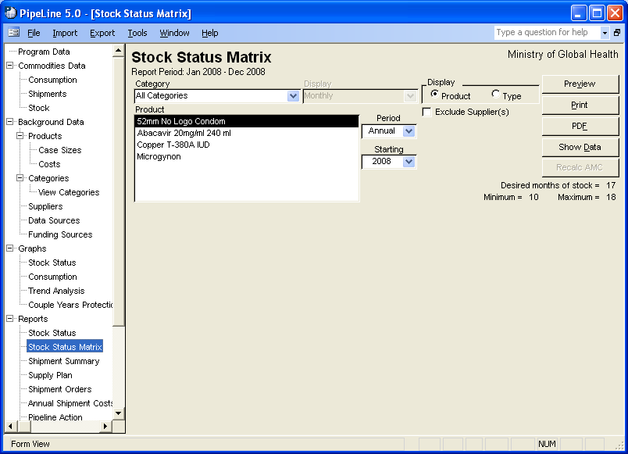
Figure 24—Stock Status Matrix screen
 | The Stock Status Matrix report was explicitly designed to display data monthly. Quarterly display is unavailable for this report. You can still display data quarterly or monthly in the original Stock Status Report.

Products and Types
PipeLine gives you the option of selecting items by Product or Type (see Figure 25).
The Product option is selected by default. To display data by Type—which is a list of Types filtered by Category—
- Click on the Type option.
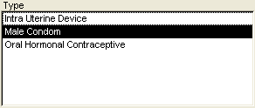
Figure 26—Display options
PipeLine changes the label of the Product box to Type and displays all Types associated with the selected category (see Figure 26).
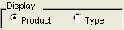
Figure 25—Display options
The Product/Type box displays the product(s) you can select to create a stock status matrix report.
- Click on the Product or Type you need to create the report.
To select multiple products or types—
- Hold down the <Ctrl> key, and click on each product you want included in the report.
Or, hold down the <Ctrl> key, and click on each type you want included in the report.
The Period and Starting fields let you determine the span of time the report will cover.
- Click on the arrow next to the Period field; select the desired report period.
- Click on the arrow next to the Starting field; select the first year of the report period.

Excluding Suppliers’ Future Planned Shipments
The Exclude Suppliers field enables you to exclude planned shipments from the Stock Status Matrix report by excluding the suppliers of these shipments from the output.
- Click on the Exclude Suppliers field.
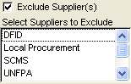
Figure 27—Select Suppliers to Exclude box The Select Suppliers To Exclude box opens, showing the suppliers of your products (see Figure 27).
- Click on the suppliers whose planned shipments you want excluded from the report.
To select more than one supplier—
- Hold down the Control key <Ctrl>, and click on each supplier you want excluded from the report.
See page 47 of this addendum for information on using the Show Data and Hide Data buttons.
See page 46 of this addendum for information on previewing, printing, or creating a PDF of the Stock Status Matrix report.

Supply Plan Report
This report is intended to help you communicate or place quantities of products on order. Over a user-defined time period, it displays consumption data in basic units and packs, and each shipment ordered (from multiple suppliers) in basic units, packs, and cases. The report could be given to shipment suppliers to help them determine shipping quantities, schedule, the most efficient shipping mode, and container configurations for freight. Depending on the quantity ordered, you have the option to round-up to the nearest case size, or to see case fractions, depending on whether or not only whole or partial cases can be ordered.
 | How is this feature different from PipeLine 4.0?  This report was not available in PipeLine 4.0. Users could not see shipment quantities in cases and basic units from any of the reports in PipeLine 4.0.

Creating the Supply Plan Report
Using stock data, you can create a Supply Plan report for any product in your program.
From the Tree View—
 | The procedure for creating a Supply Plan report is the same for every product you choose.
- Click on the Supply Plan Tree View option (under Reports) to display the Supply Plan screen (see Figure 28).
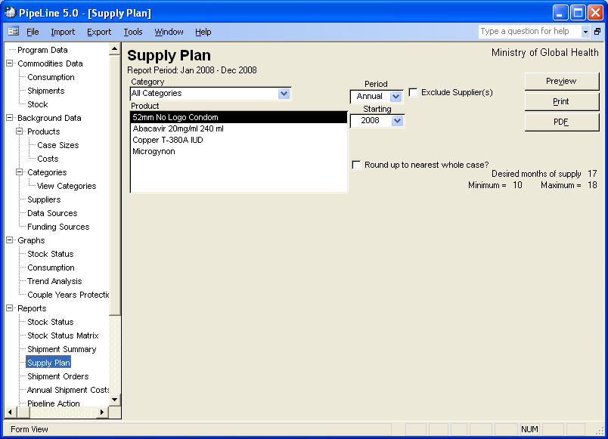
- Figure 28—Supply Plan screen Click on the arrow next to the Category field; select a category from the pull-down menu.
Or, select All Categories from the Category pull-down menu to access all products in your program.
The Period and Starting fields enable you to determine the span of time the report will cover.
- Click on the arrow next to the Period field; select the desired report period.
- Click on the arrow next to the Starting field; select the first year of the report period.
- Click on the Product you need to create the report.
To select multiple products—
- Hold down the <Ctrl> key, and click on each product you want included in the report.

Excluding Suppliers’ Future Planned Shipments
The Exclude Suppliers field enables you to exclude planned shipments from the Supply Plan report by excluding the suppliers of these shipments from the output.
- Click on the Exclude Suppliers field.
Figure 29—Select Supplier(s) to Exclude box The Select Suppliers to Exclude box opens, displaying the suppliers of your products (see Figure 29).
- Click on the suppliers whose planned shipments you want excluded from the report.
To select more than one supplier—
- Hold down the Control key <Ctrl>, and click on each supplier you want excluded from the report.
See page 47 of this addendum for information on using the Show Data and Hide Data buttons.
See page 46 of this addendum for information on previewing, printing, or creating a PDF of the Stock Status Matrix report.

Stock Status Report—See Multiple Products Over One Month
This enhancement to the Stock Status Report enables you to view data for all products, or a selected subset of products in the stock status report, for any given month. This configuration of the report is available from the original Stock Status Report screen; it gives you an additional option for viewing stock status data. For the month selected, the report displays the product name, beginning balance, any shipments received, consumption, stock adjustment, months of stock, quantity needed to reach desired months of stock, and ending balance. Multiple products can be displayed for any one month at a time; the report does not display maximum, minimum, and desired stock levels unless the levels are the same for every product selected.
 | How is this feature different from PipeLine 4.0?  This feature was not available in PipeLine 4.0. Users could only view the stock status of one product at a time, over a minimum time period of at least one year.

Creating the Stock Status Report with Multiple Products Over One Month
You can create a stock status report for any product in your program.
 | The procedure for creating a Stock Status report is the same for every product you choose.
From the Tree View—
- Click on the Stock Status Tree View option (under Reports) to display the Stock Status screen (see Figure 30).
- Click on the arrow next to the Category field; select a category from the pull-down menu.
Or, select All Categories from the Category pull-down menu to access all products in your program.
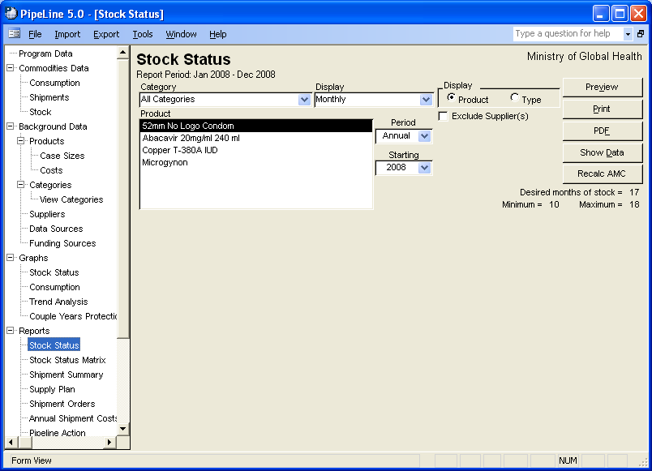
Figure 30-—Stock Status screen
The Display field enables you to create a report displaying monthly or quarterly stock data.
- Click on the arrow next to the Display field; select Monthly to display the data by month or select Quarterly to display the data by quarter.

Products and Types
Figure 31—Display options PipeLine gives you the option of selecting items by Product or Type (see Figure 31).
The Product option is selected by default. To display data by Type, which is a list of Types filtered by Category—
- Click on the Type option.
Figure 32—Display options PipeLine changes the label of the Product box to Type and displays all Types associated with the selected category (see Figure 32).
The Product/Type box displays the product(s) you can select to create a stock status report.
- Click on the Product or Type you need to create the report. For this version of the report, select multiple products to see them displayed in the enhanced format.
 | If only one product is selected, the report will display in its original format. For a description of the original format, see the PipeLine 4 User’s Guide, page 7-2.

To select multiple products or types—
- Hold down the <Ctrl> key; click on each product you want included in the report.
Or, hold down the <Ctrl> key; click on each type you want included in the report.
The Period and Starting fields enable you to determine the span of time the report will cover.
- Click on the arrow next to the Period field; select the desired month from the list.
- Click on the arrow next to the Starting field; select the year of the report period.

Excluding Suppliers’ Future Planned Shipments
The Exclude Suppliers field enables you to exclude planned shipments from the Stock Status Matrix report by excluding the suppliers of these shipments from the output.
- Click on the Exclude Suppliers field.
Figure 33—Select Suppliers to Exclude box The Select Suppliers to Exclude box opens, displaying the suppliers of your products (see Figure 33).
- Click on the suppliers whose planned shipments you want excluded from the report.
To select more than one supplier—
- Hold down the Control key <Ctrl>; click on each supplier you want excluded from the report.
See page 47 of this addendum for information on using the Show Data and Hide Data buttons.
See page 46 of this addendum for information on previewing, printing, or creating a PDF of the Stock Status Matrix report.

Selecting Predefined and User-Defined Time Periods for Graphs and Reports
You now have many time frames in which you can view graphs and reports. Data in graphs and reports can be viewed for one month, one quarter (three months, based on Western calendar quarters), six months, or annually. The most flexible option is a user-defined time that can start and end in any month and can span multiple years. If you do not use Western calendar years, or if you prefer to see your data in fiscal years, you may find the user-defined timeframe helpful.
This enhancement applies to all graphs and reports in PipeLine except the PipeLine Problem and Procurement Table reports.
 | How is this feature different from PipeLine 4.0?  This feature was not available in PipeLine 4.0. In PipeLine 4.0, users could only see data in graphs and reports annually, in either one-year increments or over multiple years.

Select Predefined Time Period
From any graph or report—
- Click on the arrow next to the Period field; select a period from the pull-down menu (see Figure 34).
- Click on the arrow next to the Starting field; select a starting year from the pull-down menu (see Figure 34).
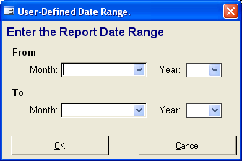
Figure 35-—User Defined Date Range window

Select User-Defined Time Period
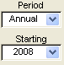
Figure 34—Selecting time period
From any graph or report—
- Click on the arrow next to the Period field; select User Defined from the pull-down menu (see Figure 34).
The User Defined Date Range window is displayed (see Figure 35).
- Click on the arrow next to the From Month field; select a starting month from the pull-down menu.
- Click on the arrow next to the From Year field; select a starting year from the pull-down menu.
- Click on the arrow next to the To Month field; select an ending month from the pull-down menu.
- Click on the arrow next to the To Year field; select an ending year from the pull-down menu.
- Click OK.

Showing and Hiding Report Data
With the exception of the Supply Plan and Annual Shipment Costs reports, PipeLine report screens have a Show Data button that enable you to quickly view the data to be included in a given report. On the Stock Status and Procurement Table reports, this feature only works when one dataset (product, type, supplier, etc.) is selected for a given category.

Showing Report Data
To use the Show Data feature—
- Select the criteria for a report based on the report’s instructions.
- Click on the Show Data button.
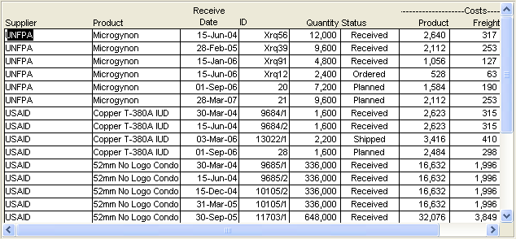
Figure 36—Example of Show Data display Data associated with the selected report are displayed on screen, similar to Figure 36. This example represents data generated by the Shipment Summary report.

Use the Scroll bar (if needed) to view all the generated data.

Hiding Report Data
The Hide Data button becomes active when report data is displayed on a given report form.
To hide the report data—
- Click on the Hide Data button.

Previewing and Printing PipeLine Reports
The procedure for previewing and printing PipeLine reports is the same for all types of reports.

Previewing a Report
To preview a report—
- Click on the Preview button.
The report is displayed onscreen. If you are satisfied with the data as presented, you can print the report from the preview screen.
- Click on the print icon to send the report to your default printer.
- Click on the close icon to return to the previous screen.

Office Links
The PipeLine Report Viewer menu has a feature that enables you to export a displayed report to one or more of the programs associated with Microsoft Office—Office Links.
To use the Office Links feature—
 | You must have Microsoft Office 2000 or above installed on your computer to use the Office Links feature.
Select the report criteria, and click on the Preview button.
- Click on the Office Links option of the Tool Bar to display the Office Links pull-down menu.
- Select the file format you want to export to from the pull-down menu.
PipeLine prompts you to name the export file.
- Type the export file’s name in the name field; click on the OK button.
PipeLine opens the Microsoft Office product associated with the file type where you exported the report.

Printing a Report
 | When PipeLine reports are exported to Excel, all numeric fields will export as numbers, enabling you to easily manipulate them.  How is this feature different from PipeLine 4.0?  In PipeLine 4.0, all reports exported to Microsoft Excel; however, many numeric fields were formatted in Excel as text. You had to convert the formatting to numeric before you could manipulate the data.
You can send a report directly to your default printer, without previewing it.
- Click on the Print button.

Creating a PDF of a Report
To create a PDF of a report without previewing it—
- Click on the PDF button.
To create a PDF of a report from the preview of the report —
- Click on the Preview button.
- Click on the Office Links option of the Tool Bar to display the Office Links pull-down menu.
- Click on the Send to PDF menu option to create a PDF of the report.
!! | To create a PDF, you must first choose a PDF writer. For more information on choosing a PDF writer, see page A-16 of the PipeLine 4 User’s Guide.

APPENDIX A

Frequently Asked questions

Does PipeLine support multiple users?
PipeLine is a stand-alone application; it should be installed on each user’s computer. However, multiple users can share the data if the data files are stored on a shared drive or server. To do this, the shared drive or server should be selected when creating and saving a new file. Other computers connected to the shared drive can then select this file when opening a data file through PipeLine. It is possible to over-write and undo another user’s changes, as there will be no indication that multiple users have a file open at the same time. Therefore, it is still recommended that only one user update the data file at any given time; however, it is possible for multiple people to update the data file simultaneously. Please note that you may receive error messages pertaining to data collisions if multiple users update the files simultaneously. Also, all computers accessing the shared data file must be running the same application version. When upgrades are released, every computer must be upgraded.

Can I import data from another application?
PipeLine allows imports from XML files created from Quantimed and other PipeLine data files. From Quantimed, PipeLine imports forecast consumption data. From other PipeLine data files, PipeLine imports shipment data. However, it is possible to import data from other sources if the XML file is designed to be accepted by PipeLine. If you want to design an XML file output from a specific application for import into PipeLine, check with the PipeLine product manager at the address on page 1 of this addendum.

Where are my graphs?
PipeLine will run on Windows XP and above. However, a known bug in Windows Vista and Windows 7 platforms cause graphs to display incorrectly on the form. If you select a graph from the tree view and it is not displayed, select your report criteria, then click the Preview button to see the graph on the report. When you close the report, the graph will display on the form, but it may disappear again if you change criteria. Another option to see the graph on the form is to minimize PipeLine and then maximize it. This will cause the screen to refresh and display the graph. We are working to resolve this issue for a future PipeLine release.

What is a category and how is it used?
A category is a group where products and other categories can be assigned. In PipeLine, you can add categories and delete categories to fit your data. You can also assign them to Parent Categories. When these changes are made, a hierarchical list of categories is created; to view it, select View Categories in the tree view. Every report screen has a Category drop-down menu. On the PipeLine Action and PipeLine Problem reports, this drop-down menu filters the data shown on the report. On all the other reports, the drop-down menus filter the list of products, types, or suppliers to choose from for that report. In both cases, subcategories are included with their parent category.

What is the difference between a category and a type?
Types are categories that have products assigned to them. Please note that products can only be assigned to one category (i.e., Type). On the View Categories screen, an asterisk (*) denotes the Types categories. On the Stock Status and Stock Status Matrix reports, you can select one or more Types to display on the report.

Does PipeLine track expiration dates of products or shipments?
PipeLine is a tool for planning shipments on a programmatic basis and for tracking program-wide stock status. Expiry dates are usually tracked in an inventory management system, often by a warehouse management system (WMS). PipeLine is not a WMS; therefore, it does not provide an easy way to track products by lots and expiry dates.

For more information, please visit deliver.jsi.com.
USAID | DELIVER PROJECT
John Snow, Inc.
1616 Fort Myer Drive, 11th Floor
Arlington, VA 22209 USA
Phone: 703-528-7474
Fax: 703-528-7480
Email: askdeliver@jsi.com
Internet: deliver.jsi.com

